Constructing Regular Octagon

Definition
# Source: AI Source: Provided by: [Data Path: Persons Table -> ID Column: 1, Name_En Column: Motasem Essam] -> From: [ChatGPT] on [7/25/2026]
Constructing a Regular Octagon is the geometric construction of an eight-sided polygon in which all eight sides are equal and all eight interior angles are equal, using exact geometric methods, typically with a straightedge and compass.
For a regular octagon $ABCDEFGH$:
$$\boxed{AB=BC=CD=DE=EF=FG=GH=HA}$$
and:
$$\boxed{∠A=∠B=∠C=∠D=∠E=∠F=∠G=∠H={135}^{∘}}$$
Each central angle is:
$$\boxed{{45}^{∘}}$$
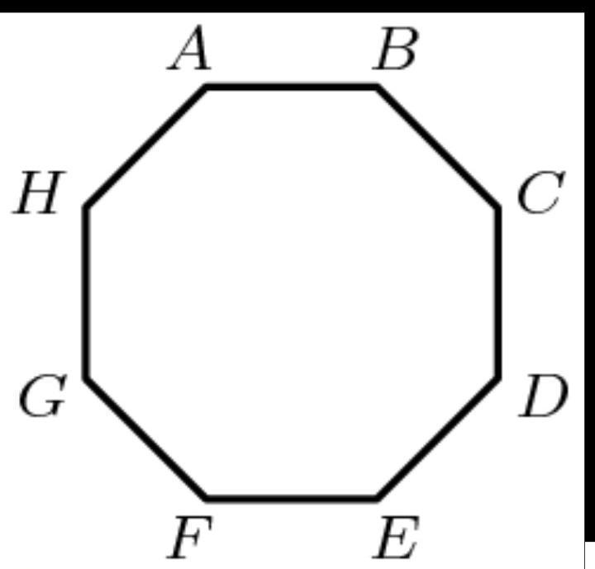
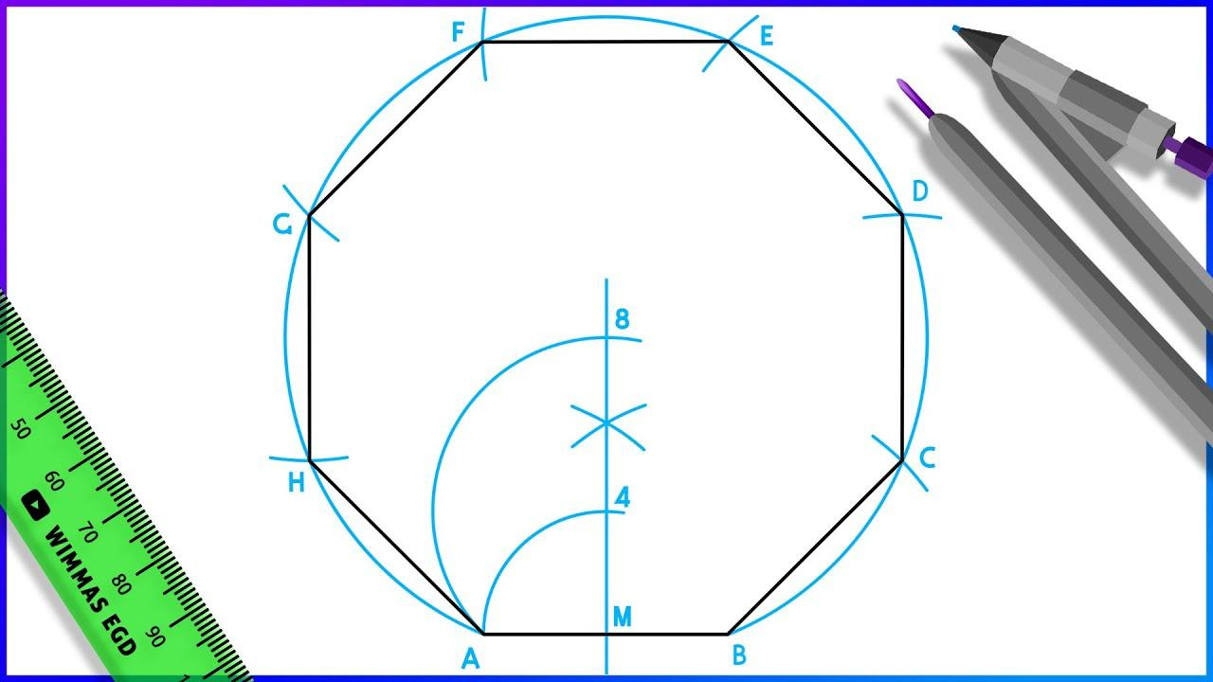
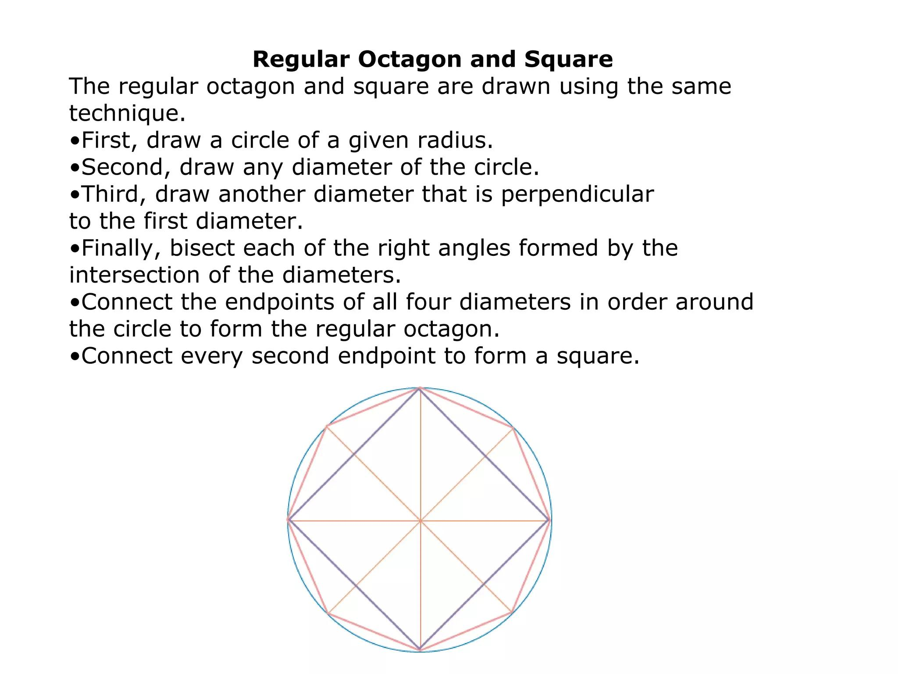
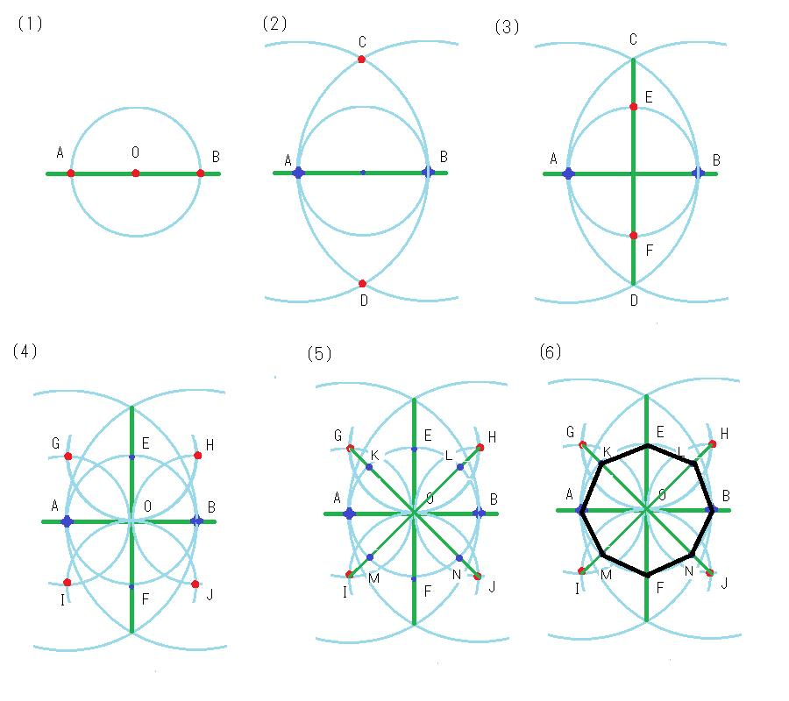

Fundamental Concept
# Source: AI Source: Provided by: [Data Path: Persons Table -> ID Column: 1, Name_En Column: Motasem Essam] -> From: [ChatGPT] on [7/25/2026]
A regular octagon is a regular polygon with:
$$n=8$$
The sum of its interior angles is:
$$\left(8-2\right){180}^{∘}={1080}^{∘}$$
Therefore, each interior angle is:
$$\frac{{1080}^{∘}}{8}={135}^{∘}$$
The central angle between consecutive vertices is:
$$\frac{{360}^{∘}}{8}={45}^{∘}$$
The regular octagon is especially convenient to construct because:
$${45}^{∘}=\frac{{90}^{∘}}{2}$$
Therefore, it can be constructed by repeatedly using perpendicular lines and angle bisectors.

Main Construction – From a Given Circumcircle
# Source: AI Source: Provided by: [Data Path: Persons Table -> ID Column: 1, Name_En Column: Motasem Essam] -> From: [ChatGPT] on [7/25/2026]
Suppose a circle with center $O$is given.
Construction Steps
- Construct a circle with center $O$.
- Draw a diameter $AC$.
- Construct a perpendicular diameter $EG$through $O$.
- This creates four right angles of:
$${90}^{∘}$$
- Bisect each ${90}^{∘}$central angle.
- The four new rays intersect the circle at:
$$B,D,F,H$$
- The eight points are:
$$A,B,C,D,E,F,G,H$$
- Connect consecutive vertices.
The result is a regular octagon.
The construction is based on:
$${90}^{∘}÷2={45}^{∘}$$
Therefore, all eight central angles are:
$$\boxed{{45}^{∘}}$$

Construction From a Given Square
# Source: AI Source: Provided by: [Data Path: Persons Table -> ID Column: 1, Name_En Column: Motasem Essam] -> From: [ChatGPT] on [7/25/2026]
A regular octagon can be constructed by cutting equal corners from a square.
Suppose a square has side length $L$.
Construction Steps
- Construct a square $ABCD$.
- At each corner, construct equal distances along the two adjacent sides.
- Connect the corresponding points near each corner.
- Choose the corner-cut length so that all eight resulting sides are equal.
- The resulting polygon is a regular octagon.
If the distance cut from each corner along each side is $x$, the new diagonal side is:
$$x\sqrt{2}$$
The remaining middle portion of each original square side has length:
$$L-2x$$
For a regular octagon:
$$L-2x=x\sqrt{2}$$
Therefore:
$$L=x\left(2+\sqrt{2}\right)$$
and:
$$\boxed{x=\frac{L}{2+\sqrt{2}}}$$
which can also be written as:
$$\boxed{x=\frac{L\left(2-\sqrt{2}\right)}{2}}$$
This produces eight equal sides.

Construction Using Central Angles
# Source: AI Source: Provided by: [Data Path: Persons Table -> ID Column: 1, Name_En Column: Motasem Essam] -> From: [ChatGPT] on [7/25/2026]
A regular octagon divides a full circle into eight equal central angles:
$$θ=\frac{{360}^{∘}}{8}={45}^{∘}$$
Therefore:
- Construct a circle.
- Mark its center $O$.
- Draw two perpendicular diameters.
- Bisect the four ${90}^{∘}$angles.
- The eight resulting rays meet the circle at the eight vertices.
- Connect consecutive points.
Thus:
$$\boxed{∠AOB=∠BOC=∠COD=∠DOE=∠EOF=∠FOG=∠GOH=∠HOA={45}^{∘}}$$

Construction Using a Given Side
# Source: AI Source: Provided by: [Data Path: Persons Table -> ID Column: 1, Name_En Column: Motasem Essam] -> From: [ChatGPT] on [7/25/2026]
If the side length $s$is given, the circumradius is:
$$\boxed{R=\frac{s}{2\sin{{22.5}^{∘}}}}$$
Since:
$$\sin{{22.5}^{∘}}=\frac{\sqrt{2-\sqrt{2}}}{2}$$
we obtain:
$$\boxed{R=\frac{s}{\sqrt{2-\sqrt{2}}}}$$
The apothem is:
$$\boxed{a=\frac{s}{2\tan{{22.5}^{∘}}}}$$
Since:
$$\tan{{22.5}^{∘}}=\sqrt{2}-1$$
then:
$$\boxed{a=\frac{s}{2\left(\sqrt{2}-1\right)}}$$
or:
$$\boxed{a=\frac{s\left(\sqrt{2}+1\right)}{2}}$$

Construction Using a Given Diagonal
# Source: AI Source: Provided by: [Data Path: Persons Table -> ID Column: 1, Name_En Column: Motasem Essam] -> From: [ChatGPT] on [7/25/2026]
A regular octagon has several types of diagonals.
The longest diagonal connects opposite vertices and is the diameter of the circumcircle:
$$\boxed{d_{\text{long}}=2R}$$
If the longest diagonal $D$is given:
$$\boxed{R=\frac{D}{2}}$$
Then:
- Construct the circle with radius $R$.
- Draw two perpendicular diameters.
- Bisect the four right angles.
- Mark the eight intersections with the circle.
- Connect consecutive vertices.
Thus, a regular octagon can be constructed from its longest diagonal.

Mathematical Properties
# Source: AI Source: Provided by: [Data Path: Persons Table -> ID Column: 1, Name_En Column: Motasem Essam] -> From: [ChatGPT] on [7/25/2026]
Number of Sides
$$\boxed{n=8}$$
Interior Angle
$$\boxed{{135}^{∘}}$$
Exterior Angle
$$\boxed{{45}^{∘}}$$
Central Angle
$$\boxed{{45}^{∘}}$$
Perimeter
If each side has length $s$:
$$\boxed{P=8s}$$
Area
The area of a regular octagon with side length $s$is:
$$\boxed{A=2\left(1+\sqrt{2}\right)s^{2}}$$
Using the apothem $a$:
$$\boxed{A=\frac{1}{2}Pa}$$
Therefore:
$$\boxed{A=4sa}$$
Circumradius
$$\boxed{R=\frac{s}{\sqrt{2-\sqrt{2}}}}$$
Apothem
$$\boxed{a=\frac{s\left(1+\sqrt{2}\right)}{2}}$$
Diagonals
A regular octagon has:
$$\boxed{\frac{8\left(8-3\right)}{2}=20}$$
diagonals.
There are three distinct diagonal lengths.
Short Diagonal
Connecting vertices separated by one vertex:
$$\boxed{d_{1}=2R\sin{{45}^{∘}}}$$
Since:
$$R=\frac{s}{2\sin{{22.5}^{∘}}}$$
this becomes:
$$\boxed{d_{1}=\left(1+\sqrt{2}\right)s}$$
Medium Diagonal
Connecting vertices separated by two vertices:
$$\boxed{d_{2}=2R\sin{{67.5}^{∘}}}$$
which gives:
$$\boxed{d_{2}=\sqrt{4+2\sqrt{2}} s}$$
Long Diagonal
Connecting opposite vertices:
$$\boxed{d_{3}=2R}$$
which gives:
$$\boxed{d_{3}=\sqrt{4+2\sqrt{2}} s}$$
More precisely, the diagonal lengths are commonly classified by step separation:
$$\boxed{2R\sin{\frac{π}{8}}, 2R\sin{\frac{2π}{8}}, 2R\sin{\frac{3π}{8}}, 2R}$$
where symmetry identifies equivalent chord lengths. In a regular octagon there are three distinct diagonal lengths in addition to the side.
Symmetry
A regular octagon has:
- 8 lines of reflection symmetry
- 8-fold rotational symmetry
Its fundamental rotational symmetry angle is:
$$\boxed{{45}^{∘}}$$
The rotations include:
$${45}^{∘}, {90}^{∘}, {135}^{∘}, {180}^{∘}, {225}^{∘}, {270}^{∘}, {315}^{∘}, {360}^{∘}$$

Construction Situations
# Source: AI Source: Provided by: [Data Path: Persons Table -> ID Column: 1, Name_En Column: Motasem Essam] -> From: [ChatGPT] on [7/25/2026]
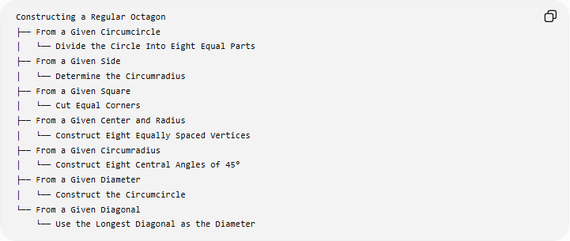
Constructing a Regular Octagon
├── From a Given Circumcircle
│ └── Divide the Circle Into Eight Equal Parts
├── From a Given Side
│ └── Determine the Circumradius
├── From a Given Square
│ └── Cut Equal Corners
├── From a Given Center and Radius
│ └── Construct Eight Equally Spaced Vertices
├── From a Given Circumradius
│ └── Construct Eight Central Angles of 45°
├── From a Given Diameter
│ └── Construct the Circumcircle
└── From a Given Diagonal
└── Use the Longest Diagonal as the Diameter
These are construction situations based on the given information, rather than different mathematical types of regular octagons.

Basic Constructions Used
# Source: AI Source: Provided by: [Data Path: Persons Table -> ID Column: 1, Name_En Column: Motasem Essam] -> From: [ChatGPT] on [7/25/2026]
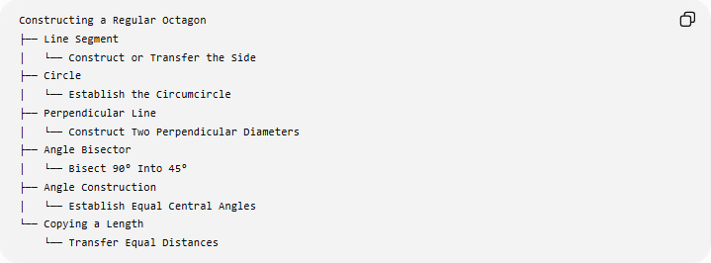
Constructing a Regular Octagon
├── Line Segment
│ └── Construct or Transfer the Side
├── Circle
│ └── Establish the Circumcircle
├── Perpendicular Line
│ └── Construct Two Perpendicular Diameters
├── Angle Bisector
│ └── Bisect 90° Into 45°
├── Angle Construction
│ └── Establish Equal Central Angles
└── Copying a Length
└── Transfer Equal Distances

Regular Octagon and Its Square
# Source: AI Source: Provided by: [Data Path: Persons Table -> ID Column: 1, Name_En Column: Motasem Essam] -> From: [ChatGPT] on [7/25/2026]
The square is an important starting figure for constructing a regular octagon.
A square has:
$$4\text{ sides}$$
while a regular octagon has:
$$8\text{ sides}$$
The octagon can be obtained by cutting off the four corners of the square with equal-length cuts.
The required corner distance is:
$$\boxed{x=\frac{L}{2+\sqrt{2}}}$$
where $L$is the side length of the original square.
This construction creates:
- 4 sides parallel to the original square's sides.
- 4 sides at ${45}^{∘}$to those sides.
- 8 equal sides overall.

Regular Octagon and Its Circumcircle
# Source: AI Source: Provided by: [Data Path: Persons Table -> ID Column: 1, Name_En Column: Motasem Essam] -> From: [ChatGPT] on [7/25/2026]
For a regular octagon $ABCDEFGH$inscribed in a circle with center $O$:
$$OA=OB=OC=OD=OE=OF=OG=OH=R$$
and:
$$∠AOB=∠BOC=∠COD=∠DOE=∠EOF=∠FOG=∠GOH=∠HOA={45}^{∘}$$
Therefore:
$$\boxed{\text{Regular Octagon}=\text{Eight Equal Chords of a Circle}}$$

Regular Octagon vs Regular Heptagon
# Source: AI Source: Provided by: [Data Path: Persons Table -> ID Column: 1, Name_En Column: Motasem Essam] -> From: [ChatGPT] on [7/25/2026]
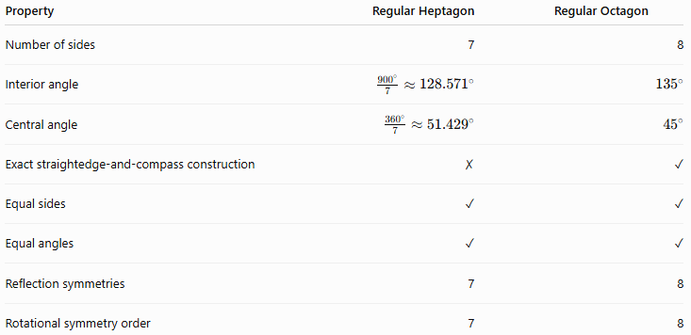
Property | Regular Heptagon | Regular Octagon
Number of sides | 7 | 8
Interior angle | $$\frac{{900}^{∘}}{7}≈{128.571}^{∘}$$ | $${135}^{∘}$$
Central angle | $$\frac{{360}^{∘}}{7}≈{51.429}^{∘}$$ | $${45}^{∘}$$
Exact straightedge-and-compass construction | ✗ | ✓
Equal sides | ✓ | ✓
Equal angles | ✓ | ✓
Reflection symmetries | 7 | 8
Rotational symmetry order | 7 | 8
The regular octagon is exactly constructible with a straightedge and compass because its central angle can be obtained by bisecting a right angle:
$${90}^{∘}→{45}^{∘}$$

Regular Octagon vs Other Regular Polygons
# Source: AI Source: Provided by: [Data Path: Persons Table -> ID Column: 1, Name_En Column: Motasem Essam] -> From: [ChatGPT] on [7/25/2026]
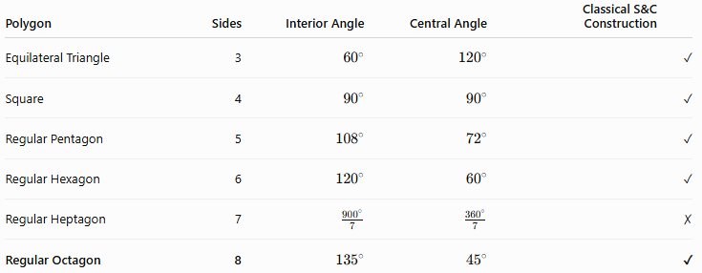
Polygon | Sides | Interior Angle | Central Angle | Classical S&C Construction
Equilateral Triangle | 3 | $${60}^{∘}$$ | $${120}^{∘}$$ | ✓
Square | 4 | $${90}^{∘}$$ | $${90}^{∘}$$ | ✓
Regular Pentagon | 5 | $${108}^{∘}$$ | $${72}^{∘}$$ | ✓
Regular Hexagon | 6 | $${120}^{∘}$$ | $${60}^{∘}$$ | ✓
Regular Heptagon | 7 | $$\frac{{900}^{∘}}{7}$$ | $$\frac{{360}^{∘}}{7}$$ | ✗
Regular Octagon | 8 | $${135}^{∘}$$ | $${45}^{∘}$$ | ✓

Classification
# Source: AI Source: Provided by: [Data Path: Persons Table -> ID Column: 1, Name_En Column: Motasem Essam] -> From: [ChatGPT] on [7/25/2026]
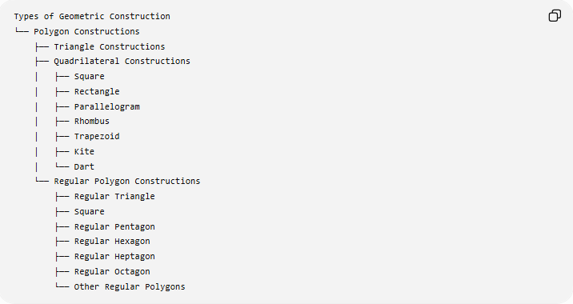
Types of Geometric Construction
└── Polygon Constructions
├── Triangle Constructions
├── Quadrilateral Constructions
│ ├── Square
│ ├── Rectangle
│ ├── Parallelogram
│ ├── Rhombus
│ ├── Trapezoid
│ ├── Kite
│ └── Dart
└── Regular Polygon Constructions
├── Regular Triangle
├── Square
├── Regular Pentagon
├── Regular Hexagon
├── Regular Heptagon
├── Regular Octagon
└── Other Regular Polygons
Detailed Classification
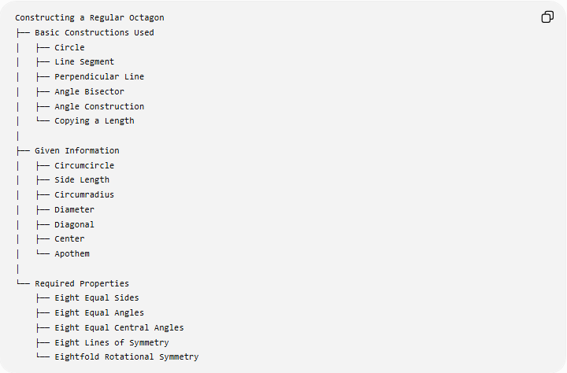
Constructing a Regular Octagon
├── Basic Constructions Used
│ ├── Circle
│ ├── Line Segment
│ ├── Perpendicular Line
│ ├── Angle Bisector
│ ├── Angle Construction
│ └── Copying a Length
│
├── Given Information
│ ├── Circumcircle
│ ├── Side Length
│ ├── Circumradius
│ ├── Diameter
│ ├── Diagonal
│ ├── Center
│ └── Apothem
│
└── Required Properties
├── Eight Equal Sides
├── Eight Equal Angles
├── Eight Equal Central Angles
├── Eight Lines of Symmetry
└── Eightfold Rotational Symmetry

Key Points
# Source: AI Source: Provided by: [Data Path: Persons Table -> ID Column: 1, Name_En Column: Motasem Essam] -> From: [ChatGPT] on [7/25/2026]
- A regular octagon has exactly 8 equal sides.
- Each interior angle is:
$$\boxed{{135}^{∘}}$$
- Each central and exterior angle is:
$$\boxed{{45}^{∘}}$$
- It can be constructed exactly using a straightedge and compass.
- A particularly simple method is to construct a circle, draw two perpendicular diameters, and bisect the resulting ${90}^{∘}$angles.
- It can also be constructed by cutting equal corners from a square.
- Its perimeter is:
$$\boxed{P=8s}$$
- Its area is:
$$\boxed{A=2\left(1+\sqrt{2}\right)s^{2}}$$
- It has 20 diagonals.
- It has 8 lines of reflection symmetry.
- It has rotational symmetry of order 8.
- Its longest diagonal is the diameter of its circumcircle.
- Unlike the regular heptagon, the regular octagon is exactly constructible with classical straightedge-and-compass methods.

Conclusion
# Source: AI Source: Provided by: [Data Path: Persons Table -> ID Column: 1, Name_En Column: Motasem Essam] -> From: [ChatGPT] on [7/25/2026]
Constructing a Regular Octagon is the exact geometric construction of an eight-sided regular polygon. Its central angle is:
$$\boxed{{45}^{∘}}$$
which makes its construction particularly straightforward because ${45}^{∘}$can be obtained by bisecting a ${90}^{∘}$angle. A regular octagon can therefore be constructed from a circumcircle, side, square, center, diameter, diagonal, or apothem.
The two especially useful constructions are:
$$\boxed{\text{Circle}→\text{Perpendicular Diameters}→\text{Bisect }{90}^{∘}→\text{8 Vertices}}$$
and:
$$\boxed{\text{Square}→\text{Cut Four Equal Corners}→\text{Regular Octagon}}$$
Thus, the regular octagon is one of the fundamental regular polygons that can be constructed exactly using classical straightedge-and-compass techniques.

